Patient Acknowledgement
For Services Not Covered By Your Dental Plan

Occasionally, patients in our office request procedures that are not covered by their dental plan. We are happy to provide these services, but want our patients to understand the financial implications. Many insurance companies are either unaware or ignore the state law below and indicate on an EOB that the patient does not owe any more for the service provided, when in fact they do own more.

For example, a patient may request a porcelain crown or filling but their dental plan only covers a metal crown or filling. The insurance company will calculate the benefit to you on the Explanation of Benefits (EOB) sheet, based upon a similar procedure covered by the plan, often referred as an “alternate benefit.” However, you received a procedure that was not covered by your dental plan. Therefore, we are allowed to bill you the difference between the benefit calculated on the EOB and our office fee for that procedure.

In 2012, the Legislature passed LB 810 to address a situation occurring with insurance dental plans, specifically, an insurance company attempting to limit the fee a dental office could charge a patient even though the dental plan did not provide a benefit for a particular procedure sought by the patient. LB 810 modified §44-7,105 which is below:

§ 44-7,105. (Effective 7/19/2012)
Notwithstanding section 44-3,131, (1) an individual or group sickness or accident policy, certificate, or subscriber contract delivered, issued for delivery, or renewed in this state and a hospital, medical, or surgical expense-incurred policy, (2) a self-funded employee benefit plan to the extent not preempted by federal law, and (3) a certificate, agreement, or contract to provide limited health services issued by a prepaid limited health service organization as defined in section 44-4702 shall not include a provision, stipulation, or agreement establishing or limiting any fees charged for dental services that are not covered by the policy, certificate, contract, agreement, or plan.

We would be happy to provide you the procedure that is covered by your dental plan. However, if you choose to receive a higher level procedure that is not covered by your plan, we will need to bill you for the difference between your plan benefit and our office fee.

We appreciate your understanding and acknowledgement of this situation.

______________________________________ _______________
Patient Signature Date

See the back of this page for
Common Examples of Limitations in a Dental Benefit Plan.

Common Examples of Limitations in Dental Benefit Plans

- Frequency Limitations - Limitation: Dental cleaning is a benefit only twice per Benefit Period. A third cleaning would not be covered by your plan.
- Topical Fluoride Applications - Limitation: Topical fluoride is a benefit only for eligible children under age 15 once every 12 consecutive months. Therefore a child over age 15 or under age 15 and receiving a second topical fluoride within 12 months is not covered.
- Periodontal Maintenance Therapy - Limitation: Periodontal Maintenance Services is available twice per year. A third Periodontal Maintenance Service in the same year would not be covered.
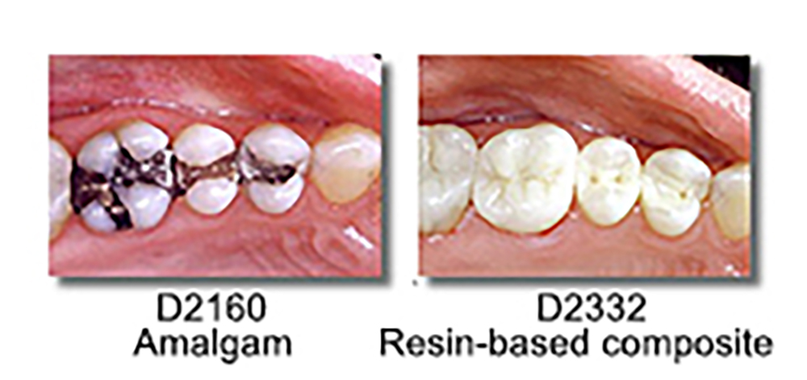
- Alternate Benefit Services. A "filling" for example, can be an amalgam filling or a composite - tooth-colored filing. Each has a separate dental code and price with the tooth-colored filling generally more expensive. Most dental benefit plans do not "cover" a tooth-colored filling and many patients do not want a silver, or amalgam filling. The tooth-colored filling is not covered by the plan. The same example applies for a steel crown (covered) and tooth-colored crown (not covered). Some dental benefit plans refer to this as the least costly treatment rule.
- Annual Benefit Cap – Most Dental Benefit Plans have an annual cap or allowance (usually between $1,000 and $1,500 per year. If any dental service is provided and you have exceeded your annual benefit cap, the service is not covered.
- Waiting Periods - Some plans require a waiting period before a patient's benefits begin to take effect. If you as the patient have not waited long enough for the benefits to begin, the service is not covered.
The above examples are only a partial list of limitations and exclusions that appear in dental benefit plans that apply to coverage.
If Dental Benefit Plan never pays for ______________, then ________________ is not “covered by the policy” and Dental Benefit Plan cannot dictate the price for that service.
Nebraska Department of Insurance letter, April 8, 2015.
Be sure to check your dental benefit plan for a complete list of limitations and exclusions.



