**The Oral Health Status of Nebraska’s Children**

**Compared to the General U.S. Population**

Good oral health is important to a child’s social, physical and mental development. Even though tooth decay can be prevented, most children in Nebraska still get cavities. To assess the current oral health status of Nebraska’s preschool and elementary school population, the Nebraska Department of Health and Human Services (DHHS) coordinated a statewide oral health survey of two population groups – children enrolled in Head Start and third grade children attending Nebraska’s public and private schools. In addition, DHHS collaborated with Building Healthy Futures to conduct a survey of another population group – third grade children attending Omaha Public Schools (OPS) where at least 50% of the students are members of a racial or ethnic minority. All of the screenings were completed in 2015-2016.

**Quick Facts**

**Head Start**

* 46% have decay experience
* 30% have untreated decay

**Statewide Third Grade**

* 64% have decay experience
* 32% have untreated decay
* 56% have dental sealants

**High Risk Omaha Third Graders**

* 68% have decay experience
* 22% have untreated decay
* 62% have dental sealants

**Oral Health Disparities**

* Children in rural counties, attending lower-income schools and Hispanic children have the highest prevalence of decay experience and untreated tooth decay in the state.

**Overall Recommendations**

* The findings presented in this data brief support the need for state wide expansion of community-based and culturally appropriate dental disease prevention programs, especially in rural areas and high need urban sites, that offer oral screenings, dental education, preventive services and proper referrals for emergency and restorative dental care to improve the overall oral health of Nebraska’s children.

***Head Start Survey:*** Head Start provides comprehensive early childhood education, health, nutrition, and parent involvement services to low-income children and their families. The family income for most Head Start children is below the federal poverty level. The Head Start survey screened 748 children between 3-5 years of age at 21 Head Start sites across Nebraska.

***Statewide Third Grade Survey:*** A total of 3,087 third grade children received a dental screening at a representative sample of 58 schools throughout Nebraska.

***OPS Third Grade Survey:*** The OPS survey screened children in schools with a high minority population; at least 50% of the students are non-white. Eighteen high minority schools participated and 1,080 children were screened.

This data brief presents information on the prevalence of tooth decay in the primary (baby) and permanent (adult) teeth of Nebraska’s Head Start and third grade children compared to the general U.S. population screened as part of the National Health and Nutrition Examination Survey (NHANES). It also describes the prevalence of dental sealants among third grade children. Dental sealants are a plastic-like coating applied to the chewing surfaces of children’s permanent teeth to prevent tooth decay.

**Prevalence of Decay Experience.**

Decay experience means that a child has had tooth decay in the primary (baby) and/or permanent (adult) teeth in his or her lifetime. Decay experience can be past (fillings, crowns, or teeth that have been extracted because of decay) or present (untreated tooth decay or cavities). In 2015-2016, about one-of-two Head Start children (46%) and almost two-of-three third grade children (64%) in Nebraska had decay experience; compared to 23% of 2-5 year olds and 52% of third grade children in the general U.S. population (NHANES, 2011-2012 and 2005-2010). The percent of children in high-minority OPS schools with decay experience was 68%. It should be noted that most Head Start children live at or below the federal poverty level while the U.S. estimate for children 2-5 years of age includes children from all income brackets.

Figure 1. Prevalence of decay experience in the primary and permanent teeth of Nebraska’s Head Start and third grade children compared to children in the general U.S. population

Sources: Nebraska Oral Health Survey, 2015-2016

National Health and Nutrition Examination Survey (NHANES), 2005-2010 and 2011-2012

**Prevalence of Untreated Decay.**

Left untreated, tooth decay can have serious consequences, including needless pain and suffering, difficulty chewing (which compromises children’s nutrition and can slow their development), difficulty speaking and lost days in school. Three-of-ten (30%) low-income Head Start children in Nebraska have untreated tooth decay; slightly higher than the prevalence among low-income children in the general U.S. population (25%) but almost three times higher than the prevalence among higher-income U.S. preschool children (11%). Among third grade children, almost one-third of Nebraska’s children (32%) had untreated tooth decay; compared to 23% of third grade children in the general U.S. population (NHANES, 2005-2010). The percent of third grade children in high-minority OPS schools with untreated decay was 22%, similar to the national average.

Figure 2. Prevalence of untreated decay in the primary and permanent teeth of Nebraska’s Head Start and third grade children compared to children in the general U.S. population

Sources: Nebraska Oral Health Survey, 2015-2016

National Health and Nutrition Examination Survey (NHANES), 2005-2010 and 2011-2012

**Prevalence of Dental Sealants.**

Dental sealants are thin plastic coatings that are applied to the grooves on the chewing surfaces of the back adult teeth to protect them from tooth decay. Most tooth decay in children will occur on these surfaces. Sealants protect the chewing surfaces from tooth decay by keeping germs and food particles out of these grooves. More than half (56%) of Nebraska’s third grade children had at least one dental sealant; compared to 32% of the general U.S. population in third grade (NHANES, 2005-2010). The percent of children in high-minority OPS schools with dental sealants was 62%, higher than the state average.

Figure 3. Prevalence of dental sealants in the permanent molar teeth of Nebraska’s third grade children compared to the general U.S. population in third grade

Sources: Nebraska Oral Health Survey, 2015-2016

National Health and Nutrition Examination Survey (NHANES), 2005-2010

**Oral Health Disparities.**

Influential socio-demographic indicators for oral health disparities in the United States include geographic location poverty status, and race and ethnicity.

*Disparities among Nebraska’s Third Grade Children:* In Nebraska, lower income schools (schools with a high percentage of the students eligible for the National School Lunch Program (NSLP))[1] have a significantly higher prevalence of decay experience compared to higher income schools with a low percent of students eligible for the NSLP. Compared to non-Hispanic white children, Hispanic children have a significantly higher prevalence of decay experience. In terms of geography, children living in rural counties have a significantly higher prevalence of both decay experience and untreated decay. There are no significant differences in the prevalence of dental sealants among racial/ethnic groups or by socioeconomic status but children living in rural counties have a significantly lower prevalence of this protective dental service. Refer to Figure 4 (blue/race, green/location, orange/income).

*Disparities among Nebraska’s Head Start Children:* Head Start children living in rural counties have a significantly higher prevalence of decay experience and untreated decay than those living in urban counties. For Head Start children, there are no significant differences in the prevalence of decay experience or untreated decay among racial/ethnic groups. Refer to Figure 5 (blue/race, orange/location).

Figure 4. Prevalence of decay experience, untreated tooth decay and dental sealants among Nebraska’s **Third Grade Children** by race/ethnicity, geographic location and percent of children in a school eligible for the National School Lunch Program (NSLP), 2015-2016

**Decay experience**

**Untreated decay**

**Dental sealants**

* Significantly different than non-Hispanic whites (p<0.05), + significantly different than urban, ^ significantly different than < 25% on NSLP (p<0.05)

Figure 5. Prevalence of decay experience and untreated tooth decay among Nebraska’s **Head Start Children** by race/ethnicity and geographic location, 2015-2016

**Decay experience**

**Untreated Decay**

* Significantly different than non-Hispanic whites (p<0.05), + significantly different than urban, ^ significantly different than < 25% on NSLP (p<0.05)

**Data Source and Methods.**

This data brief is based on data from the Nebraska Oral Health Survey which was conducted during 2015-2016. The Nebraska survey screened three different population groups – Head Start, third grade children from a statewide representative sample of public and private elementary schools, and third grade children attending Omaha Public Schools where at least 50% of the students are a racial or ethnic minority.

*Sample Selection for Statewide Head Start:* The sampling frame consisted of all Head Start centers in Nebraska located in counties with 20 or more Head Start enrollees. The sampling frame was ordered by county and a systematic probability proportional to size sampling scheme was used to select 23 centers. After the sample was selected, the Head Start grantee for Lancaster County changed and the four Lancaster County sites in the original sample were closed and they were replaced by two new sites. Because of this, a total of 21 sites rather than 23 sites participated, and a total of 748 children were screened.

*Sample Selection for Statewide Third Grade Survey:* The sampling frame consisted of all public and private schools with 15 or more children in third grade. The sampling frame was stratified by urban/rural status of the county and percent of the school’s students eligible for the National School Lunch Program (NSLP). A systematic probability proportional to size sampling scheme was used to select 60 schools of which 58 agreed to participate. Of the 3668 third grade children enrolled in the 58 participating schools, 3087 were screened for a response rate of 84%.

*Sample selection for the OPS high-minority third grade survey:* The sampling frame included all Omaha Public Schools with 15 or more children in third grade and a minority enrollment of 50% or more. The sampling frame was ordered by percent of the school’s students eligible for NSLP. A systematic probability proportional to size sampling scheme was used to select 19 schools of which 18 agreed to participate. Of the 1293 third grade children enrolled in the 18 participating schools, 1080 were screened for a response rate of 84%.

Trained and calibrated Nebraska professional dentists and public health hygienists completed the screenings at the participating Head Start centers and elementary schools. The following information was collected for each child: age, gender, ethnicity, race, presence of untreated decay in the primary (baby) or permanent (adult) teeth, presence of treated decay in the primary or permanent teeth, urgency of need for dental care, and presence of dental sealants in the permanent first molar teeth (third grade students only). We used the ASTDD *Basic Screening Survey* clinical indicator definitions and data collection protocols.[2]

All statistical analyses were performed using the complex survey procedures within SAS (Version 9.3; SAS Institute Inc., Cary, NC). Sample weights were used to produce population estimates based on selection probabilities.

**Definitions.**

Untreated Decay: Describes dental cavities or tooth decay that have not received appropriate treatment.

Decay Experience: Refers to having untreated decay or a dental filling, crown, or other type of restorative dental material. Also includes teeth that were extracted because of tooth decay.

Dental Sealants: Describes plastic-like coatings applied to the chewing surfaces of back teeth. The applied sealant resin bonds into the grooves of teeth to form a protective physical barrier.

**Data tables.**

**Table 1**: Prevalence of decay experience and untreated tooth decay among **Nebraska’s Head Start Children** aged 3-5 years by selected characteristics, 2015-2016

|  |  |  |  |  |  |  |  |
| --- | --- | --- | --- | --- | --- | --- | --- |
| **Characteristic** | **Decay Experience** | | | | **Untreated Decay** | | |
| **Percent** | **Lower CL** | **Upper CL** | | **Percent** | **Lower CL** | **Upper CL** |
| All Head Start children (n=748) | 46.2 | 38.4 | | 54.1 | 29.5 | 21.3 | 37.6 |
| Race/Ethnicity |  |  | |  |  |  |  |
| White non-Hispanic (n=295) | 46.6 | 39.4 | | 53.8 | 32.0 | 22.8 | 41.2 |
| Black non-Hispanic (n=106) | 34.0 | 17.1 | | 50.8 | 12.1 | 2.7 | 21.5 |
| Hispanic (n=259) | 50.7 | 40.5 | | 60.9 | 34.4 | 21.6 | 47.3 |
| Other/Unknown (n=95) | 51.7 | 30.1 | | 73.2 | 33.4 | 12.8 | 54.0 |
| Geography |  |  | |  |  |  |  |
| Rural (n=391) | 55.5 | 48.5 | | 62.5 | 40.6 | 33.1 | 48.1 |
| Urban (n=357) | 34.9 | 24.2 | | 45.6 | 15.9 | 7.6 | 24.1 |

Lower CL: Lower 95% confidence limit; Upper CL: Upper 95% confidence limit

**Table 2**: Prevalence of decay experience and untreated tooth decay in the primary and permanent teeth and prevalence of dental sealants on permanent molar teeth among **Nebraska’s Third Grade Children** by selected characteristics, 2015-2016

|  |  |  |  |  |  |  |  |  |  |  |
| --- | --- | --- | --- | --- | --- | --- | --- | --- | --- | --- |
| **Characteristic** | **Decay Experience** | | | | **Untreated Decay** | | | **Dental Sealants** | | |
| **Percent** | **Lower CL** | **Upper CL** | | **Percent** | **Lower CL** | **Upper CL** | **Percent** | **Lower CL** | **Upper CL** |
| All 3rd grade children (n=3,087) | 63.9 | 59.5 | | 68.3 | 32.0 | 28.2 | 35.8 | 56.2 | 51.5 | 61.0 |
| Race/ethnicity |  |  | |  |  |  |  |  |  |  |
| White non-Hispanic (n=2,137) | 59.7 | 54.9 | | 64.5 | 32.0 | 27.4 | 36.6 | 55.7 | 50.1 | 61.2 |
| Black non-Hispanic (n=180) | 66.1 | 57.9 | | 74.3 | 24.0 | 13.7 | 34.3 | 59.1 | 43.4 | 74.7 |
| Hispanic (n=544) | 78.5 | 72.5 | | 84.5 | 35.6 | 28.6 | 42.6 | 56.6 | 47.3 | 65.9 |
| Other/Unknown (n=226) | 64.1 | 56.3 | | 71.8 | 31.4 | 21.3 | 41.6 | 57.7 | 48.1 | 67.2 |
| Geography |  |  | |  |  |  |  |  |  |  |
| Rural (n=1,039) | 81.4 | 78.5 | | 84.2 | 53.3 | 48.0 | 58.5 | 48.6 | 42.1 | 55.2 |
| Urban (n=2,048) | 54.6 | 48.1 | | 61.2 | 20.7 | 15.6 | 25.8 | 60.3 | 53.9 | 66.6 |
| Percent eligible for NSLP |  |  | |  |  |  |  |  |  |  |
| < 25% eligible (n=964) | 43.5 | 33.9 | | 53.1 | 17.8 | 9.3 | 26.3 | 60.8 | 51.5 | 70.2 |
| 25-49% eligible (n=4804) | 69.7 | 63.5 | | 76.0 | 39.5 | 30.5 | 48.5 | 51.9 | 42.6 | 61.2 |
| 50-74% eligible (n=775) | 72.2 | 63.2 | | 81.1 | 42.4 | 30.6 | 54.2 | 49.3 | 40.3 | 58.2 |
| > 75% eligible (n=544) | 75.0 | 68.0 | | 81.9 | 29.7 | 20.9 | 38.4 | 63.8 | 53.9 | 73.7 |

NSLP: National school lunch program; Lower CL: Lower 95% confidence limit; Upper CL: Upper 95% confidence limit

**Table 3**: Prevalence of decay experience and untreated tooth decay in the primary and permanent teeth and prevalence of dental sealants on permanent molar teeth among **Omaha Public School Third Grade Children** attending high-minority schools by selected characteristics, 2015-2016

|  |  |  |  |  |  |  |  |  |  |  |
| --- | --- | --- | --- | --- | --- | --- | --- | --- | --- | --- |
| **Characteristic** | **Decay Experience** | | | | **Untreated Decay** | | | **Dental Sealants** | | |
| **Percent** | **Lower CL** | **Upper CL** | | **Percent** | **Lower CL** | **Upper CL** | **Percent** | **Lower CL** | **Upper CL** |
| All OPS children attending high minority schools (n=1,080) | 68.3 | 64.7 | | 71.8 | 21.5 | 16.4 | 26.5 | 61.7 | 55.5 | 68.0 |
| Race/ethnicity |  |  | |  |  |  |  |  |  |  |
| White non-Hispanic (n=235) | 63.7 | 55.1 | | 72.2 | 16.6 | 12.6 | 20.7 | 60.5 | 53.8 | 67.2 |
| Black non-Hispanic (n=238) | 67.2 | 61.2 | | 73.3 | 24.3 | 15.4 | 33.1 | 66.1 | 54.1 | 78.2 |
| Hispanic (n=506) | 69.8 | 60.9 | | 78.7 | 18.5 | 13.1 | 23.9 | 61.7 | 53.9 | 69.5 |
| Other/Unknown (n=101) | 76.3 | 70.0 | | 82.5 | 37.2 | 24.3 | 50.1 | 50.1 | 36.9 | 63.4 |
| Percent eligible for NSLP |  |  | |  |  |  |  |  |  |  |
| 50-74% eligible (n=193) | 69.6 | 63.4 | | 75.8 | 16.0 | 7.3 | 24.6 | 60.0 | 48.3 | 71.7 |
| > 75% eligible (n=887) | 67.9 | 63.7 | | 72.1 | 23.0 | 17.5 | 28.5 | 62.2 | 54.9 | 69.5 |

NSLP: National school lunch program; Lower CL: Lower 95% confidence limit; Upper CL: Upper 95% confidence limit

This survey report was produced by a national consultant from the Association of State and Territorial Dental Directors who analyzed statewide oral health screening field data. Dental surveillance information was collected from dentists and public health hygienists who had participated in the survey. This data brief was further reviewed by the DHHS Office of Oral Health and Dentistry in July 2017.

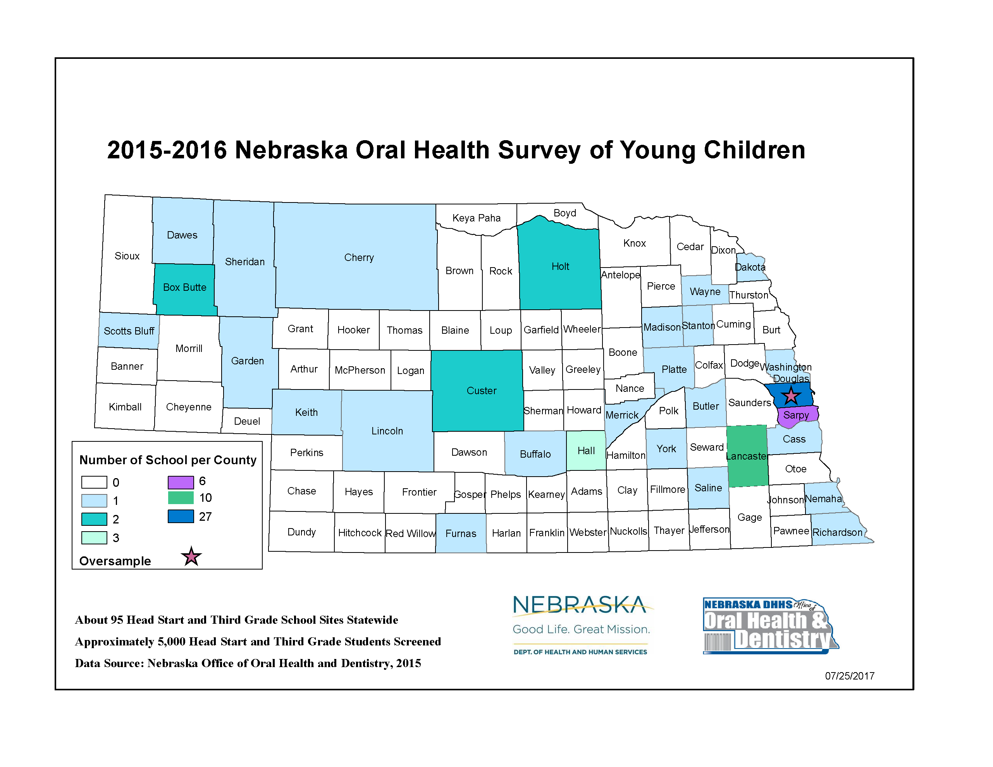

1. To be eligible for the NSLP, the child must be from a household whose income is below 185% of the federal poverty level.
2. Association of State and Territorial Dental Directors. Basic screening surveys: an approach to monitoring community oral health. Available at: <http://www.astdd.org/basic-screening-survey-tool>.